(Draft Content and Format for an Annual Departmental Faculty Equity Report)

<Department Name>

Annual Faculty Rank, Tenure, Leadership, and Salary Report

Through Fall 2015

(The data presented in this “Report Template” include faculty and students across all 3 UW campuses for illustrative purposes only.)

Table of Contents
Foreword 2
Rank and Tenure by Gender through Fall 2015 3
Trends from 2007-2015 4
Gender by Rank (Figure 1) 4
Gender by Tenure (Figure 2) 5
Faculty Hiring, Retention, and Separations 6
Trends in Faculty Hires by Rank, Gender, and Race/Ethnicity (Table 1) 6
Trends in Faculty Retentions by Rank, Gender, and Race/Ethnicity (Table 2) 6
Trends in Faculty Separations by Rank, Gender, and Race/Ethnicity (Table 3) 6
Salary Levels 7
Regression Outcomes 7
Race/Ethnicity 8
Race/Ethnicity for <Department Name> Faculty Fall 2015 (Table 4) 8
Race/Ethnicity in WA State and the U.S.: 2010 Census. (Table 5) 8
Race/Ethnicity Distribution of Faculty and Students from 2007-2015 (Figure 3) 9
Trends in Race/Ethnicity by Tenure from 2007-2015 (Figure 4) 10
Trends in Race/Ethnicity by Rank from 2007-2015 (Figure 5) 11
Leadership Over the Unit’s <number of years> Year History 12
School Leadership (Deans and Chairs) over its <# of years> Year History (Table 6) 12
Key Findings for <Department Name> 13
Policies in Place to Address Equity 13
Recommendations 13
Data Sources 13

Foreword:
Address the following:
- Purpose of report
- Who is intended to receive the report
- Who generated the report
- What datasets were used
- What subset of the department’s faculty is represented in this report and why: For example, the report may focus on the subset of faculty with primary appointments in the Department because they are the subset that the Department has the authority to oversee hiring, retention, salary, and promotion.
- etc

Rank and Tenure by Gender in Fall 2015
Among (Assist, Assoc, Full) Professors (Research, WOT, Tenured, Clinical) with Primary Appointment in <Department> (N = __).
Faculty data came from the Academic Personnel Demographic Trends Tableau Dataset.
N %
What proportion of the 2015 Fall quarter student enrollment in <Depart.Name> are female? __/__ __%
What proportion of faculty in <Depart. Name> are women? __/__ __%
RANK
What proportion of Assistant Professor positions are held by women? __/__ __%
What proportion of Assistant Professor positions are held by women? __/__ __%
What proportion of Associate Professor positions are held by women? __/__ __%
What proportion of Full Professor positions are held by women? __/__ __%
TENURE
What proportion of faculty positions in <Depart. Name> are tenured/tenure-track? __/__ __%
What proportion of <Depart.Name> positions are tenured/tenure-track by Rank? Assistant __/__ __%
Associate __/__ __%
Full __/__ __%

What proportion of tenured positions in <Depart. Name> are held by women? __/__ __%
What proportion of tenured positions in <Depart. Name> are held by men? __/__ __%

What proportion of women are tenured/tenure-track? __/__ __%
What proportion of men are tenured/tenure-track? __/__ __%

What proportion of Full Professor women are tenured? __/__ __%
What proportion of Full Professor men are tenured? __/__ __%%

What proportion of Associate Professor women are tenured? __/__ __%
What proportion of Associate Professor men are tenured? __/__ __%

What proportion of Assistant. Professor women are tenure-track? __/__ __%
What proportion of Assistant Professor men are tenure-track? __/__ __%

Trends: Gender by Rank from 2007 through 2015
Figure 1: Gender by Rank by Year (2007-2015)
Full  Professors | 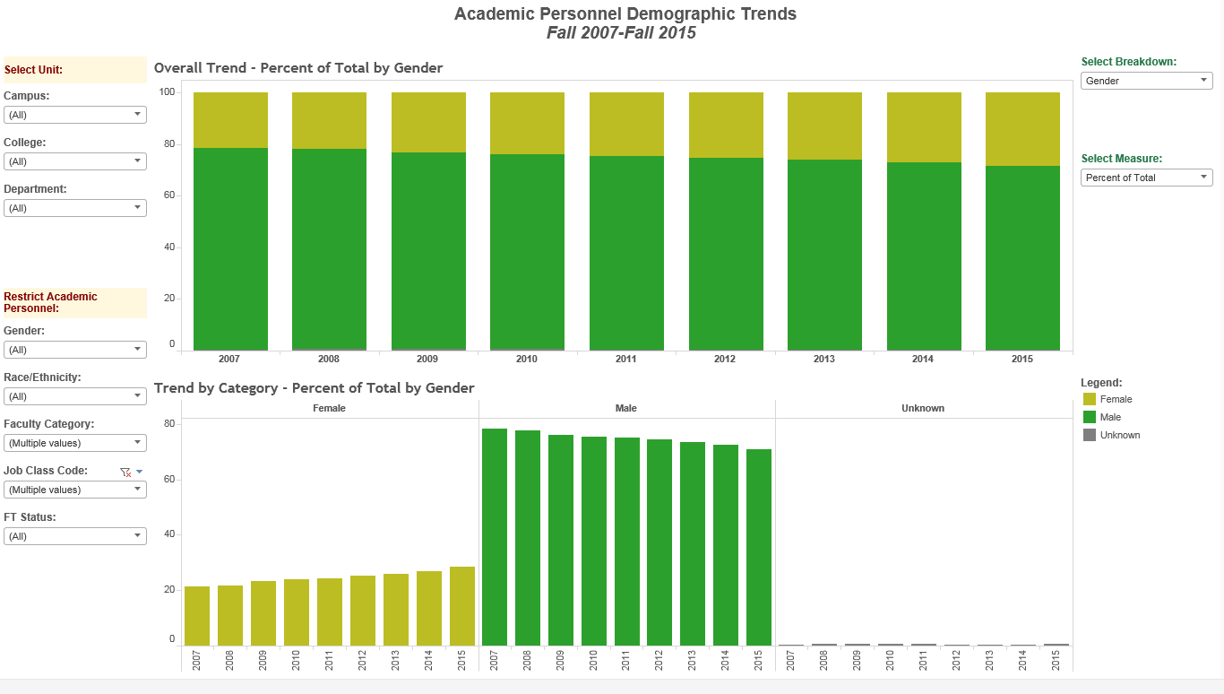
Associate  Professors | 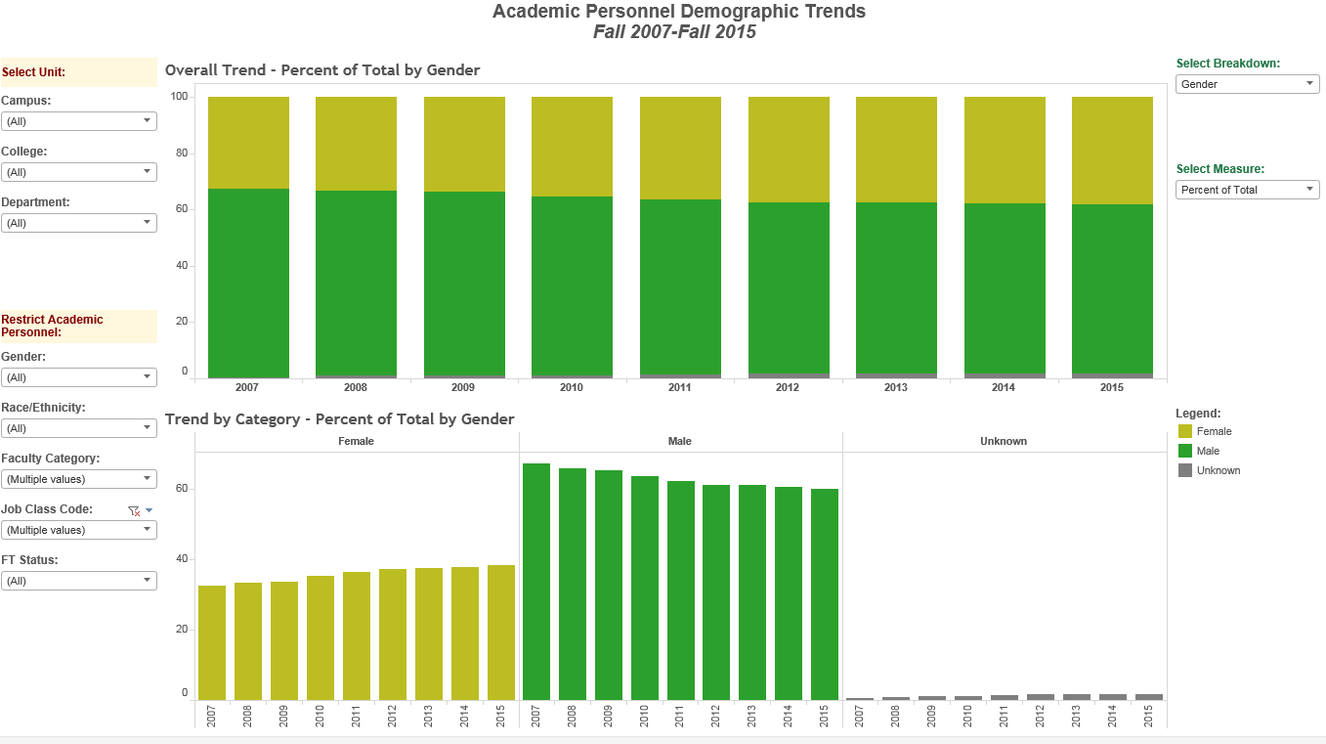
Assistant  Professors | 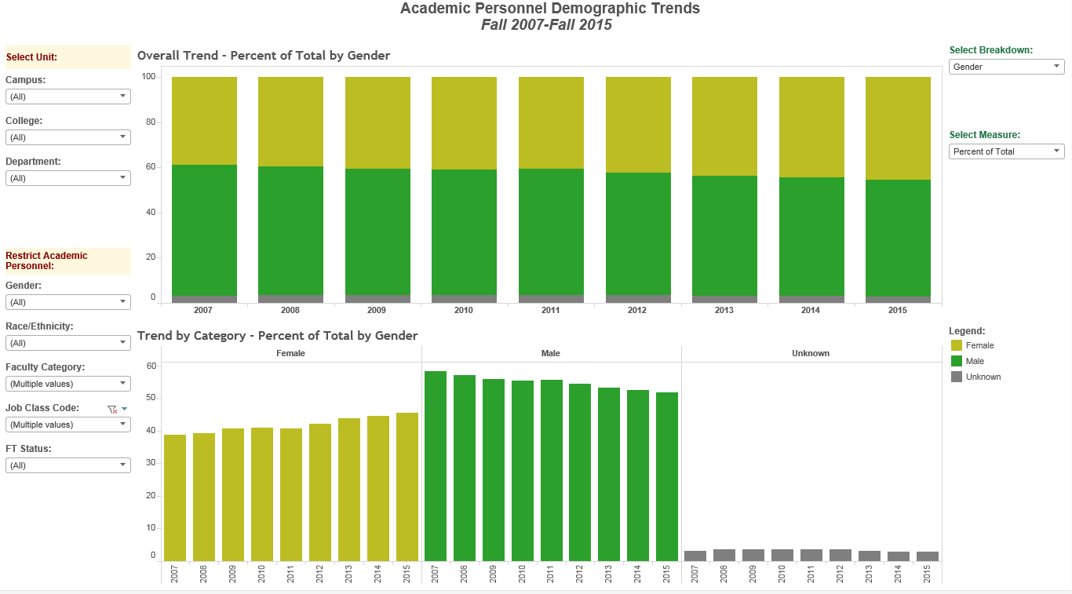
Source: Faculty Demographic Data in Tableau (Dec 2016)

Trends: Gender among Tenured Faculty from 2007 through 2015

Figure 2: Gender among Tenured / Tenure Track Faculty by Year (2007-2015)
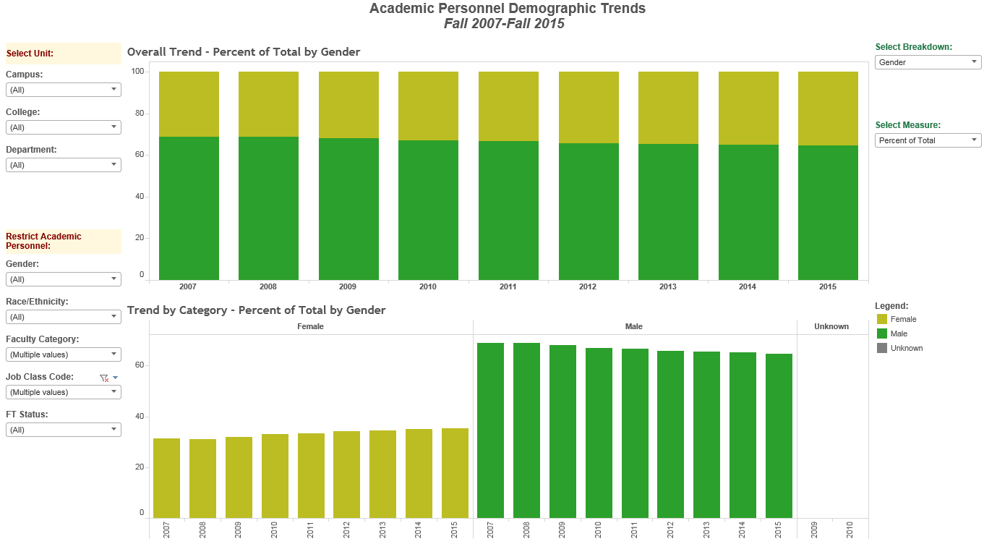
Source: Faculty Demographic Data in Tableau (Dec 2016)

Faculty Hiring, Retention, and Separations
Among (Assistant, Associate, Full) Professors (Research, WOT, Regular, Clinical) and Instructional Faculty with Primary Appointment in <Department Name> in Fall 2015.

Table 1. Trends in Faculty Hires by Rank, Gender, and Race/Ethnicity (fictitious data)
 | Female n (row %) |  | Male n (row %)
Fiscal Year | Caucasian | Not Caucasian | Caucasian | Not Caucasian
2015
Lecturer | 220 (67%) | 120 (33%) | 0 (0%) | 0 (0%)
Assistant Professor | 120 (50%) | 0 (0%) | 0 (0%) | 120 (50%)
Associate Professor | 0 (0%) | 120 (100%) | 0 (0%) | 0 (0%)
Full Professor | 0 (0%) | 0 (0%) | 120 (50%) | 120 (50%)
Source: <name of data source>

Table 2. Trends in Faculty Retentions by Gender and Race/Ethnicity (fictitious data)
 | Female n (row %) |  | Male n (row %)
Fiscal Year | Caucasian | Not Caucasian | Caucasian | Not Caucasian
2015
Retention offer requested by faculty | 100 (33%) | 0 (0%) | 200 (67%) | 0 (0%)
Retention offer initiated by Dept. | 0 (0%) | 0 (0%) | 0 (0%) | 100 (100%)
Retentions approved by Provost | 0 (0%) | N/A | 200 (67%) | 1 (33%)
Retentions denied | 100 (100%) | N/A | 0 (0%) | 0 (0%)
Faculty remained in department | 0 (0%) | N/A | 200 (67%) | 10 (33%)
Faculty left department | 100 (100%) | N/A | 0 (0%) | 0 (0%)
Source: <name of data source>

Table 3. Trends in Faculty Separations by Gender and Race/Ethnicity (fictitious data)
 | Female n (row %) |  | Male n (row %)
Fiscal Year | Caucasian | Not Caucasian | Caucasian | Not Caucasian
2015
Retirement | 100 (33%) | 100 (33%) | 100 (33%) | 0 (0%)
Resignation | 100 (100%) | 0 (0%) | 0 (0%) | 0 (0%)
Death | 0 (0%) | 0 (0%) | 0 (0%) | 0 (0%)
Source: <name of data source>

Salary Levels in 2015

Regression Outcomes

Regression analyses using the <Departmental Name> Dataset document annual salaries in 2015 for female faculty were on average $_____ <more/less> than male faculty, after adjustment for Rank (assistant, associate, full professor), years since highest degree was earned, and presence/absence of a MD degree. The model explained __% of the variation in salaries across <n> faculty members.

The <Departmental Name> Dataset does not include race/ethnicity, thus analyses evaluating salary levels by race/ethnicity could not be conducted.

Race / Ethnicity

Table 4. Race/Ethnicity for <Department Name> Faculty in Fall 2015
 | White | Black | Asian | Latino | Am. Ind. | Pac. Is. | Multiple | Not Reported | Total Non-White
UW | 63.7% | 1.3% | 11.6% | 3.2% | 0.3% | 0.1% | 1.4% | 18.4% | 36.2%
Source: Faculty Demographic Data in Tableau (Dec 2016)

Table 5. Race/Ethnicity in WA State and the U.S. (2010 Census)
 | White | Black | Asian | Latino | Am. Ind. | Pac. Is. | Mixed | Other | Total Non-White
WA State | 72.5% | 3.4% | 7.1% | 11.2% | 1.3% | 0.6% | 3.7% | 0.2% | 27.5%
US | 63.8% | 12.2% | 4.7% | 16.4% | 0.7% | 0.2% | 1.9% | 0.2% | 36.2%

Figure 3. Race/Ethnicity for <Department Name> Faculty and Students from 2007-2015
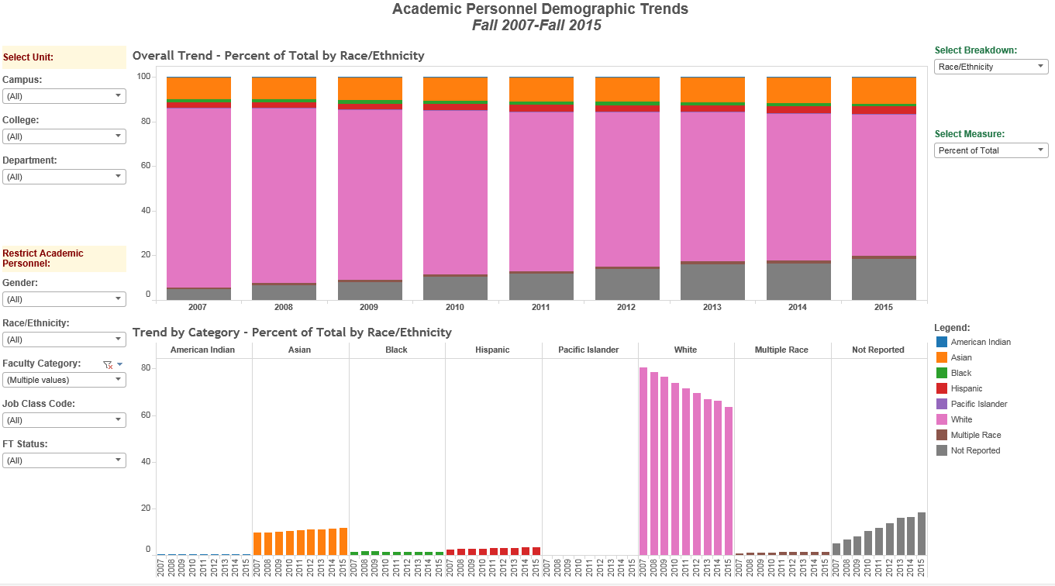
A. Includes (Assistant, Associate, Full) Professors (Research, WOT, Regular, Clinical) and Instructional Faculty with Primary Appointment in <Department Name> through Fall 2015
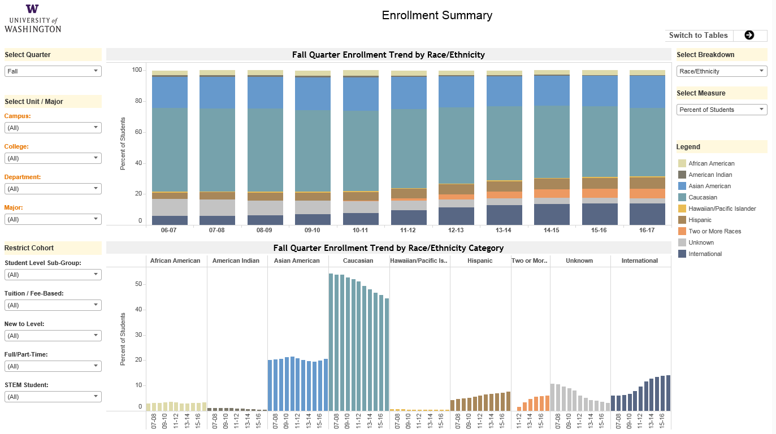
B. Student Race/Ethnicity Distribution for <Department Name>

Trends: Race/Ethnicity among Tenure/TenureTrack Faculty from 2007 through 2015

Figure 4: Race/Ethnicity among Tenure/TenureTrack Faculty by Year (2007-2015).

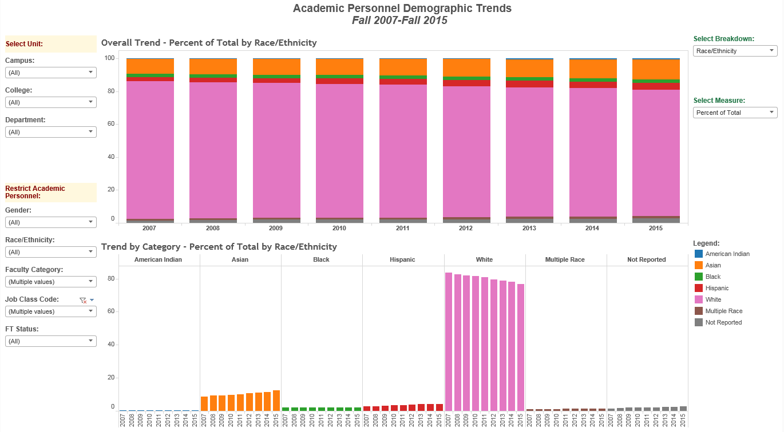
Source: Faculty Demographic Data in Tableau (Dec 2016)

Trends: Race/Ethnicity by Rank from 2007 through 2015
Figure 5: Race by Rank by Year (2007-2015)
Full  Professors | 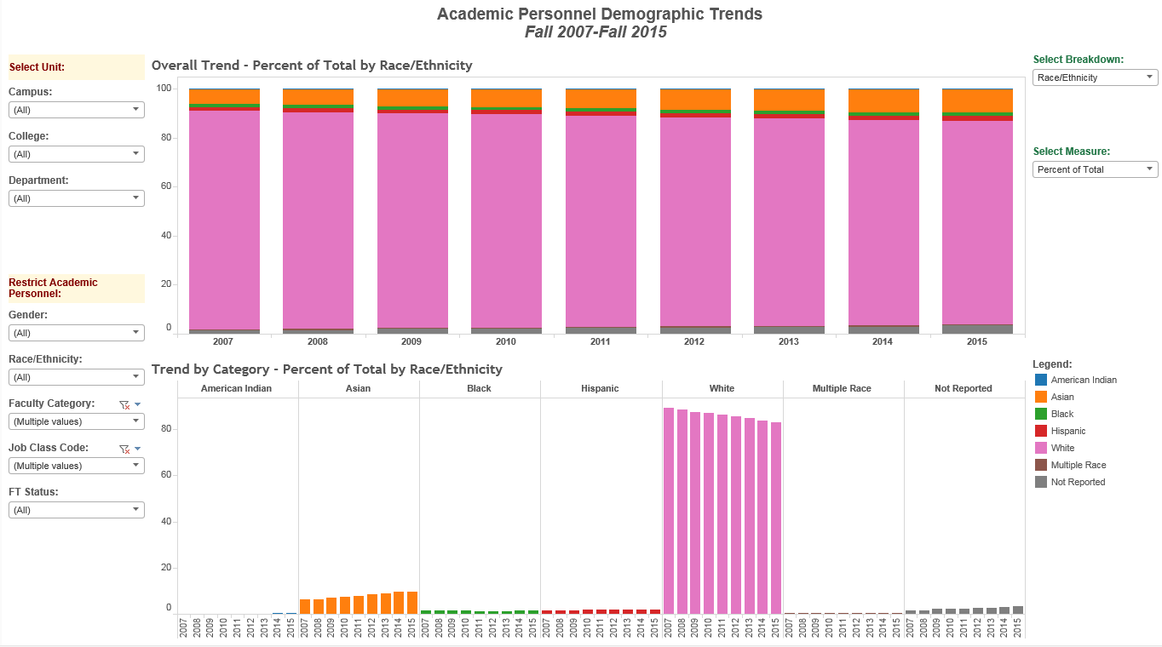
Associate  Professors | 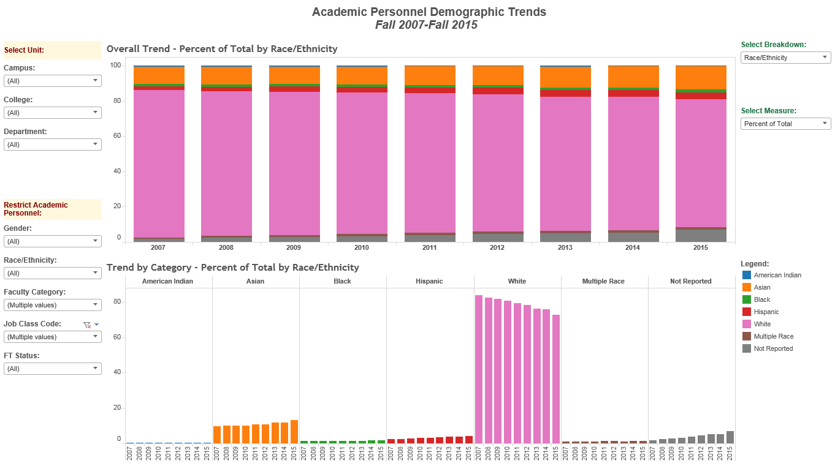
Assistant  Professors | 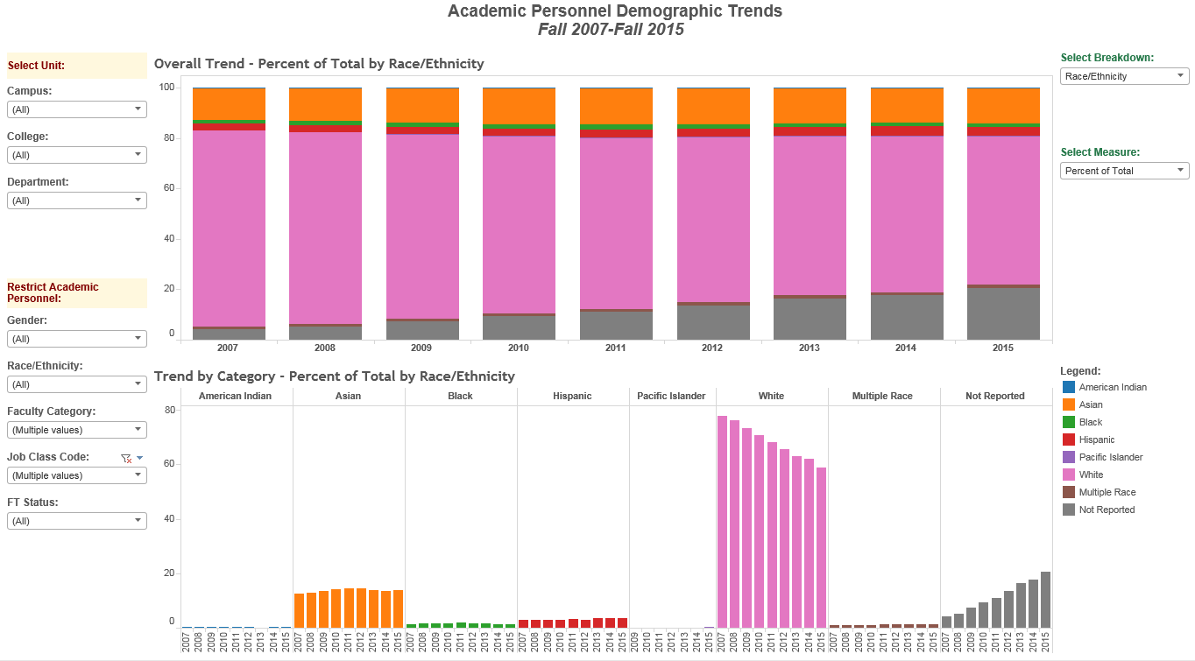
Source: Faculty Demographic Data in Tableau (Dec 2016)

<Name of School> Leadership over its <number of years> Year History

<School Name> was founded in <year>
In the <n> year history of the <School Name>:
- There have been <N> Deans (<n> women, <n> men).
- There have been <n> Chairs of <Department Name> (<n> women, <n> men).
- Data on race/ethnicity by individual were not available, but it would appear that minorities are under-represented in the Leadership.
- The Dean’s Council in <year> is __% male (<n> women, <n> men).

Table 6. School Leadership (Deans and Chairs) over its <N> Year History
Position / Department | Name | Number of Years | Period Served
DEANS | <name>
 | <name>
 | <name>
 | <name>
 | <name>
 | <name>
CHAIRS Department 1 | <name>
 | <name>
 | <name>
 | <name>
 | <name>
 | <name>
 | <name>
 | <name>
Department 2 | <name>
 | <name>
 | <name>
 | <name>
 | <name>
 | <name>
Department 3 | <name>
 | <name>
 | <name>
 | <name>
 | <name>
 | <name>
 | <name>
 | <name>
Department <n> | <name>
 | <name>
 | <name>
 | <name>
 | <name>
 | <name>
 | <name>

Key Findings for <Department Name>
- Women in 2015 held 35% of the tenured positions in <Department Name>. Women held 31% of the tenured positions in the year 2007.
- Women in 2015 held 29% of the Full Professor positions in <Department Name>. Women held 21% of the Full Professor positions in the year 2007.
- School-wide, annual salaries in 2015 for female faculty were on average $_____ <more/less> than for male faculty after adjustment for Rank and years since PhD or MD.
- <N, (%)> of the Departmental Chairs have been women.
- The proportion of non-white faculty in <Department Name> in 2015 (__ %) falls <above/below> State (27.5%) and U.S. (36.2%) distributions. It also falls <above/below> the proportion of non-white students enrolled in <Department Name> in 2015 (56%)
Policies in Place to address Equity
- List policies…..

Recommendations
- Begin a school-wide conversation among colleagues about equity issues.
- Departments must prioritize and reassess their policies for recruitment, advancement, and compensation of under-represented faculty (women and/or persons of color). The Diversity at the UW website offers resources/tools for addressing these issues.
- Identify the factors contributing to the inequities.
- Propose and implement immediate and long term actions to achieve equity. Conduct annual reviews to assess and report progress.
Data Sources:
Student Data: Fall Quarter Enrollment Trend by Race/Ethnicity Tableau Dashboard
https://bitools.uw.edu/#/views/10-EnrollmentSummary/10V-EnrollmentSummary?:iid=8
Faculty Data: Academic Personnel Demographic Trends Fall 2007-Fall 2015 Tableau Dashboard
https://bitools.uw.edu/#/views/AcademicPersonnelDemographicTrends_0/FacultyDemographicTrends?:iid=2

Requires NetID to log into. Computer must be connected to the UW internet.

